“MAJOR PROJECT”

By

Arshdeep Singh

Level-6

Table of Contents

Project Proposal 3

Project Scope 3

Project Specifications 3

Target Audience 3

Project Deliverables 4

Resource Requirements 4

Project Tasks and Milestones 4

Project Assumptions 5

Project Report 5

Non- Functional 5

Detail Design 6

Home Page 6

Customers Page 6

Products Page 7

Staffs page 7

Location page 7

Sells page 8

Project Testing 9

User Manual 9

Summary 9

System Configuration 9

User Access Levels 9

# 

# 

# Project Proposal

This project aims to implement an online website named “INTERCOM”. With the help of this website one can buy mobiles easily and cost effectively. In this website, there are admin and client. Admin can register of new clients , view their profile, edit and delete them. Admin can also edit, delete and access details of the registered clients. Moreover, admin can edit, delete and access details of the products . Clients can view profiles of products and can buy them if they are available. New clients can signup for free. Admin can register new data admin for the site.

## Project Scope

The scope of this project is to implement an website named “INTERCOM” with the help of which user can buy best Products . The duration of the project is 20 working days which is equals to 3 weeks.

## Project Specifications

* Login/Logout by admin and clients.
* Add, edit, delete and check details of products by admin
* Admin can edit, delete and check details of the clients.
* Admin can register new admins.
* Clients can view profiles of the professionals and can buy.
* New Clients can sign up for the website.

## Target Audience

Normal users and anyone who is interested in buying mobile phones from the age of 18 and up to 100 years will go.

## Project Deliverables

The deliverables of the project are:

|  |  |
| --- | --- |
| **Deliverable** | **Description** |
| Final Report | This is the final report |
| Documentation | This depicts the documentation of the project |
| Testing | All the test details will be covered in this part. |
|  |  |

## Resource Requirements

The technologies used in this project are as follows:

* Asp.net MVC Framework
* 64-bit Processor and 4 GB or more RAM
* Identity framework- ASP
* Windows Operating System- 10
* Microsoft word for documentation.
* Microsoft Excel.

## Project Tasks and Milestones

The table below shows the Project Tasks and Milestones

|  |  |
| --- | --- |
| **Tasks** | **Weeks** |
| Research and analysis | 1-2 |
| Planning and first kick of meeting Project Proposal document. | 1-2 |
| Design of Database | 1-2 |
| UI design | 1-2 |
| Implementation of Identity Framework | 2-3 |
| Coding for admin and Client | 2-3 |
| Testing | 2-3 |
| Final Documentation | 2-3 |

## Project Assumptions

While doing the implementation, following assumption are made:

* One admin and client will be there to login when the website will be designed and implemented.
* Admin can only register new admin if he/she will be signing first.
* website will be open source.

# Project Report

#### Functional and Non-Functional

The functional requirements and non-functional requirements of this project are as follows:

|  |  |
| --- | --- |
| Users | Functional |
| Admin | * Manage products, add, edit, delete and check details. * Login/Logout * Register new data admins * Edit, delete and check details of the clients. * Edit, delete and access details of the products. |
| Clients | * View Profiles of the Professionals. * Society management. * New clients can signup |
| Non- Functional | | |
| * Project will be compatible on all browsers and devices. * Security and fast load time of the project. * High performance and limited access for the clients. | | |

## Detail Design

### Home Page

This page is the main landing page of the website. In this page there are options buttons – Customer , staffs , products , location , sells , register , login which when click open next page .

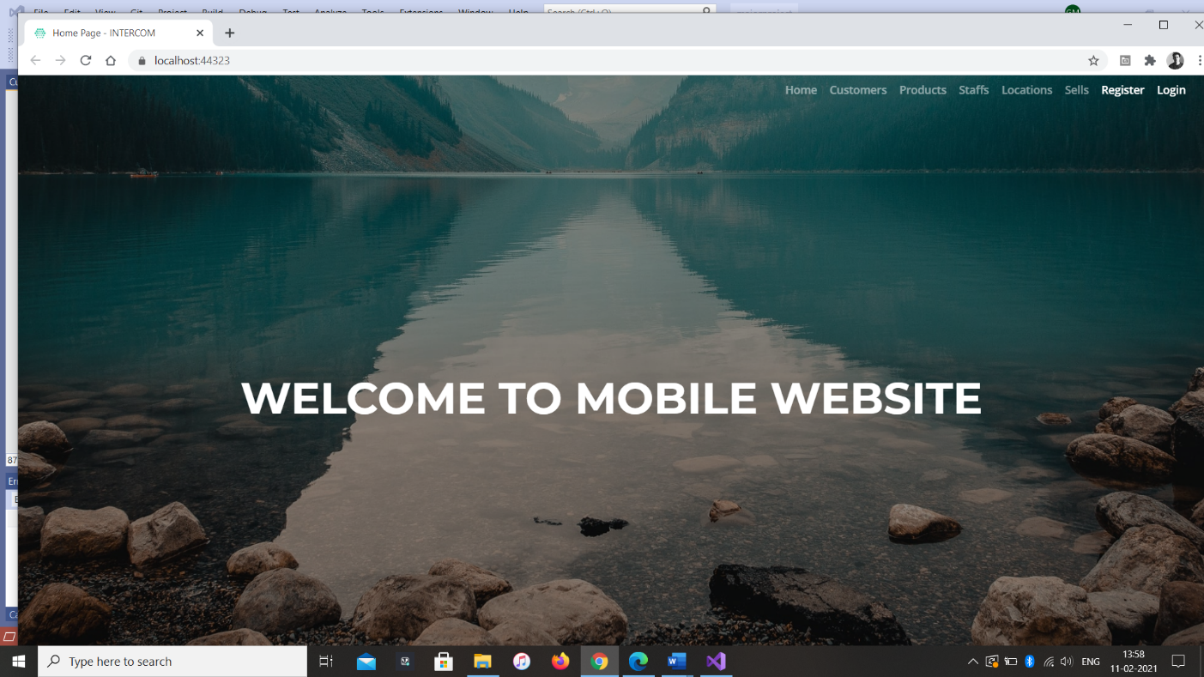

### Customers Page

Admin can add new customers with the help of this page, edit their details and remove the information, while unauthorized users can only view the data. And user can contact the company .

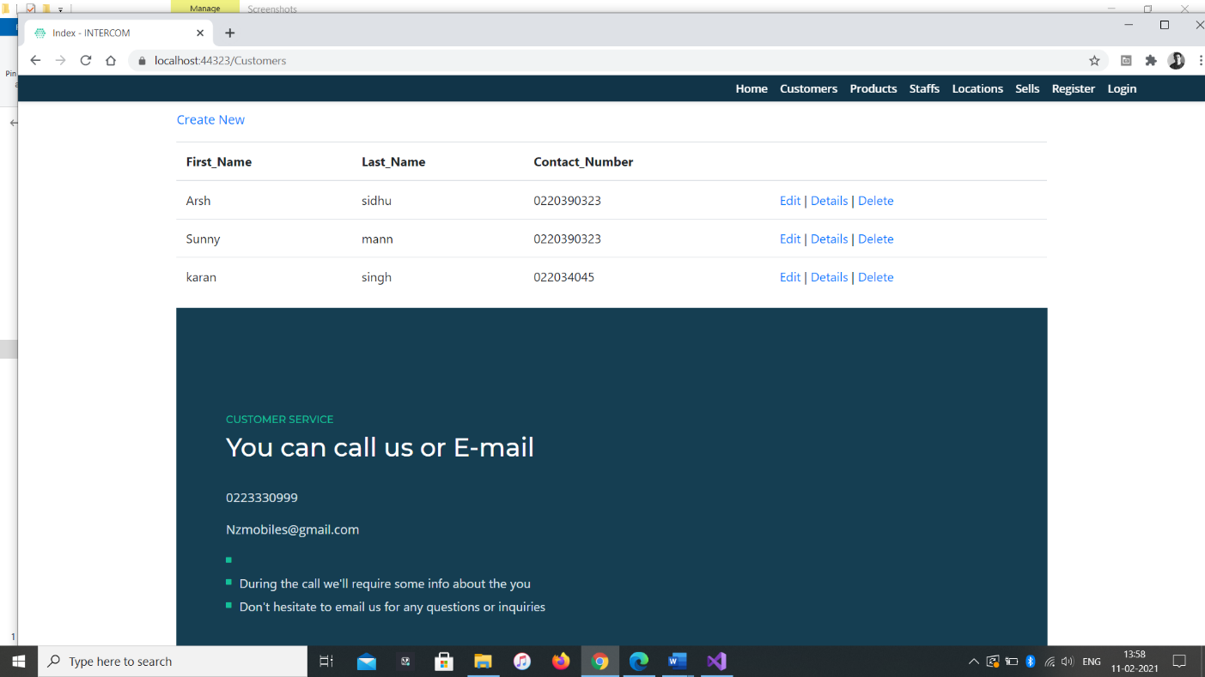

### Products Page

In This page admin registered add new products and edit the details and remove the information, and user only see the products and check price of products.

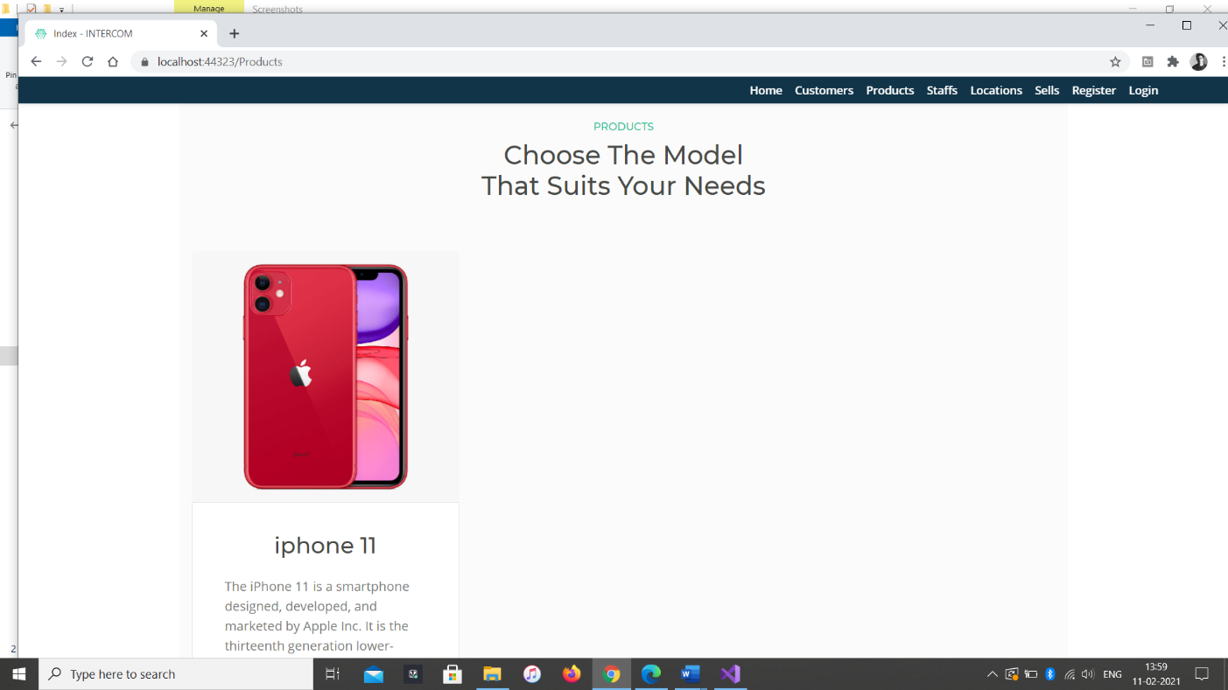

### Staff Page

Admin users can add new staff details with the support of this page, edit their details and remove the information, while unauthorized users can only view the data.

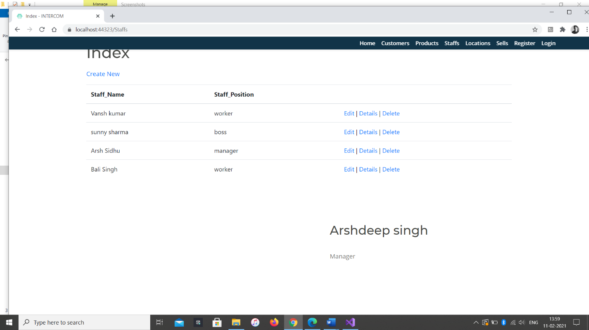

### Location Page

This page shows the store location and some contact details in this page.

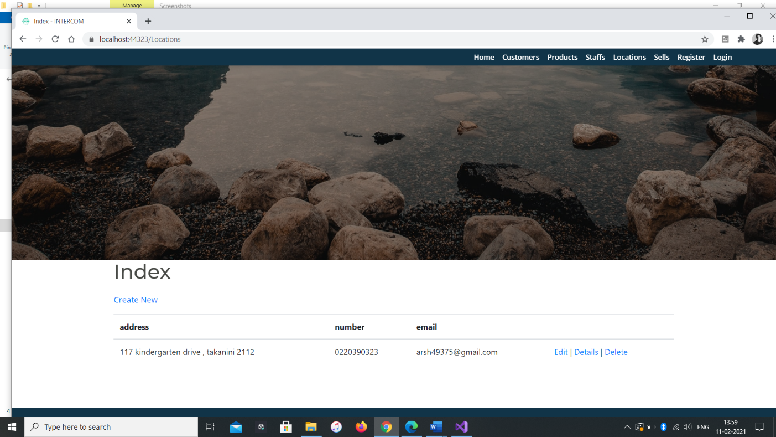

### Sells Page

The page will show the information about the specific products that the products is purchased by customer from which store, as all pages can be added, edited and removed only by admin.

### Sell page view by user

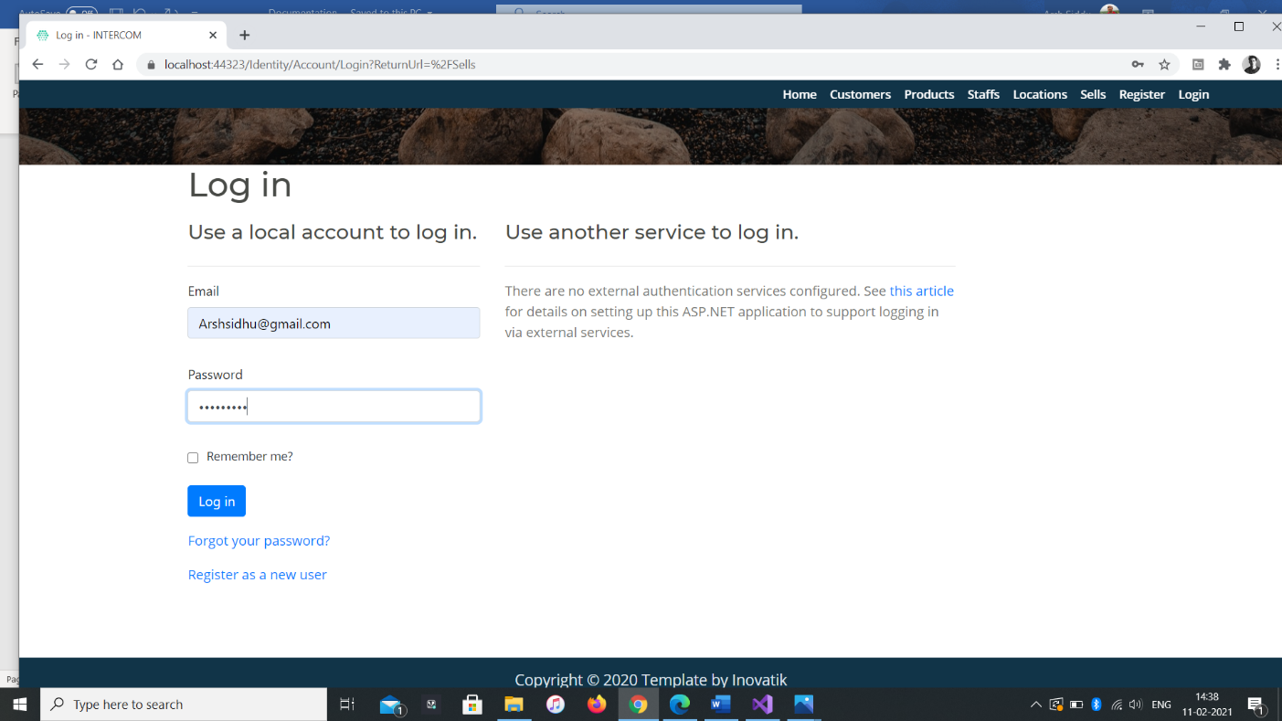

### Sells Page view by admin

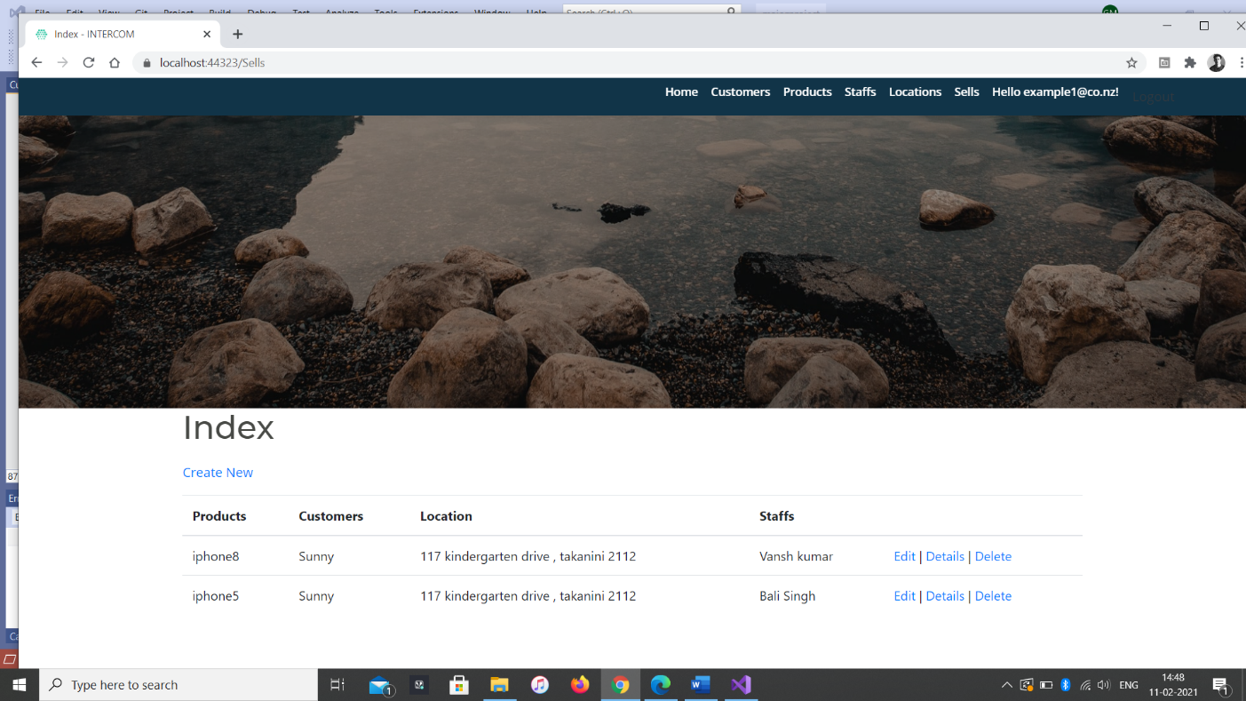

# User Manual

With the help of “INTERCOM” website you can buy products easily and cost effectively. In this website, Admin can register new products, view their profile, edit and delete them. Admin can also edit, delete and access details of the registered clients. Moreover, admin can edit, delete and access details of the clients. New clients can sign up for the application for free. Admin can register new data admin for the site.

|  |  |
| --- | --- |
| TESTING | ANSWERS |

|  |  |  |  |  |  |
| --- | --- | --- | --- | --- | --- |
| **No.** | **Question** | **Disagree** | **Normal** | **Agree** | **Strongly Agree** |
| 1 | Is the system complex? |  |  |  |  |
| 2 | Is it Easy to use? |  |  |  |  |
| 3 | Most people would learn to use this system very quickly |  |  |  |  |
| 4 | I felt very confident using the system |  |  |  |  |
| 5 | I found the various functions in this system were well integrated |  |  |  |  |
| 6 | I found the system very bulky to use |  |  |  |  |
| 7 | I will use the system frequently |  |  |  |  |

## Summary

### System Configuration

Society management website will be useful to buy a good professional at your fingertips.

### User Access Levels

Only registered users can access the features of society management website.

* **Admin:** Admin has full access of the website can register new admins.
* **Clients:** All clients are having limited access and all clients are managed by the admin. New clients can register themselves.